Employment History:
- Naval Air Development Center (1969- 1996)
  - Airborne magnetometer development for “towed birds”, aircraft and UAV’s, imaging radar, SAR, modeling Earth’s magnetic field constituents from d.c. to 2.0 Hz, laser probing of ocean structure, solar/magnetospheric/ionospheric relationships, superconducting sensors, co-operative university research, grant/proposal writing, remote sensing, management of multi-million dollar research program
- Texas Instruments (1996-1999)
  - Miniature magnetometer system development, modeling exotic and hypothetical magnetic field sources and associated field strength and structure
- Lockheed Martin (1999 -2010)
  - Space mission design and analysis, spacecraft configurations, Earth coverage, orbit/constellation design, orbit maintenance, space environment issues, spacecraft power, orbital debris, BMD, renewable energy
- Science Dimensions (2010 – present)
  - Preparing a book on the research and development of magnetometers for airborne Department of Defense (DoD) sensors for anti-submarine warfare (ASW)
  - Guest Science Writer for local newspaper in Doylestown, PA, The Intelligencer
  - Promoting Improvements in Science Education
    - High Schools should plan a Total Solar Eclipse Science Expedition

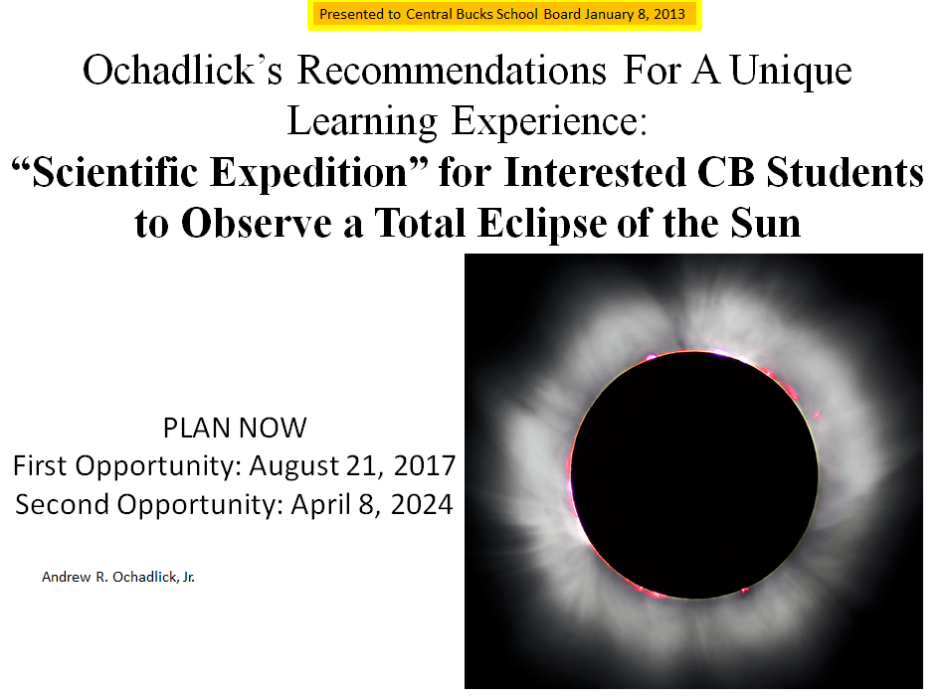

    - High Schools should consider a Bench Top NMR Spectrometer
